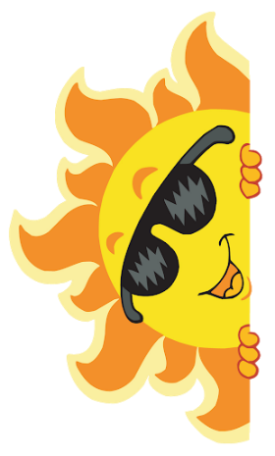
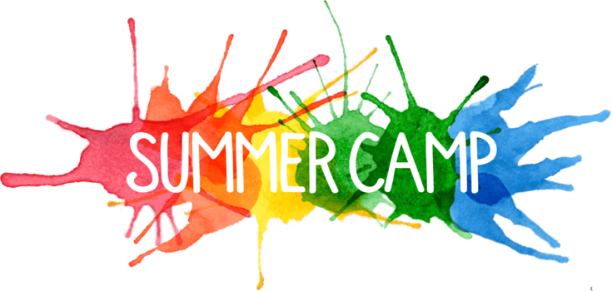
120 West American Canyon Road M-11
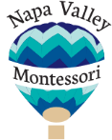
American Canyon, CA 94503
www.napavalleymontessori.com

Elementary Summer Camp 2020
Join us for 2-week sessions as we discover and learn about the following topics.
Everyday Science and Experiments  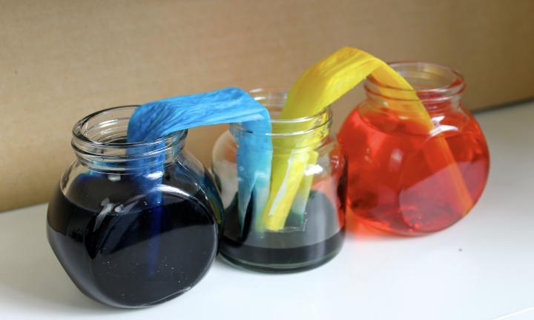 | Maker’s Lab Including Recycled Creations  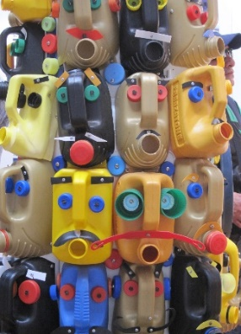
Cooking, Culture and Creativity | Botany, Gardening and Outdoor Exploration  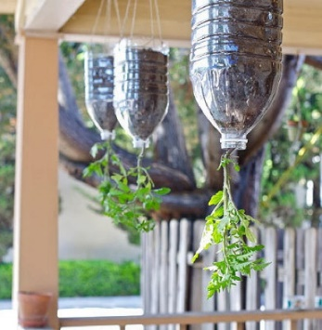
We provide a small, engaging environment with hands on experiences for children ages 5 years and up.

