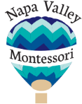

120 West American Canyon Road M-11
American Canyon, CA 94503
www.napavalleymontessori.com

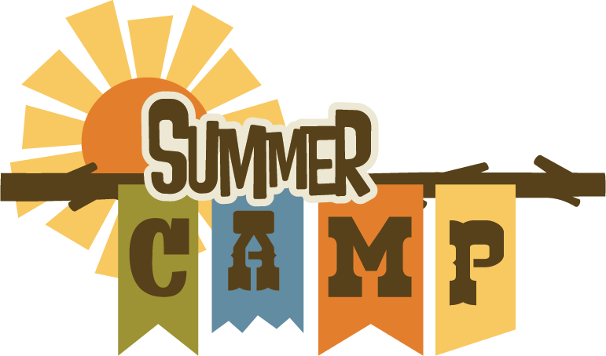
Who: Children from 2 ½ - 5yrs.
When: July and August 2020
Where: Napa Valley Montessori
Why: To learn and have fun all summer long!
Register at:
info@napavalleymontessori.com

Full and Part Time options are available
Napa Valley Montessori provides a safe, caring environment for children to grow and learn daily. We offer a variety of hands-on Projects and Lessons. During summer camp we will integrate each week's theme into our curriculum. Feel free to contact us Via Email for further information.
Encouraging Exploration That's Educational.

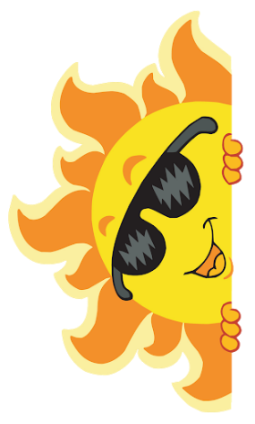

ENROLL TODAY FOR A SUMMER OF FUN!
Session 1:
Week of July 3rd and July 10th
For this session we will learn All about Bugs.
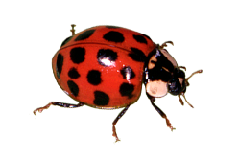
Session 2:
Week of July 17th and July 24th
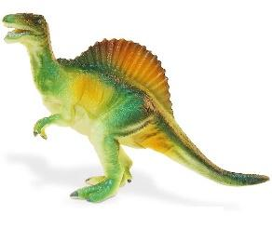
For this session we will learn about Dinosaurs.

Session 3:
Week of July 31st and August 7th
For this session we will learn about the solar system.

Session 4:
Week of August 14th and 21st
For this session we will learn all about Transportation.

