Primary Montessori Summer Camp 2017

Who: Children from 2 ½ - 5 years
When: July and August 2017
Where: Napa Valley Montessori
Why: To learn all summer long!
Register at:
info@napavalleymontessori.com

Full and Part Time options are available
Napa Valley Montessori provides a safe, caring environment for children to grow and learn on a daily basis. We offer a variety of hands on lessons to encourage exploration and capture the child’s interest.
ENROLL TODAY FOR A SUMMER OF FUN!
Session 1:
Week of July 3rd and July 10th

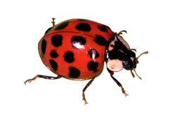
Bugs
Session 2:
Week of July 17th and July 24th
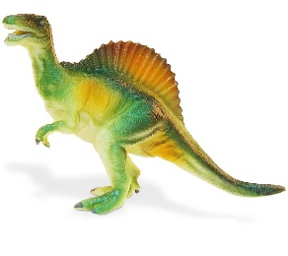
Dinosaurs
Session 3:
Week of July 31st and August 7th

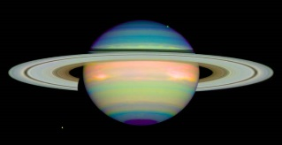

Solar System
Session 4:
Week of August 14th and 21st
Transportation

