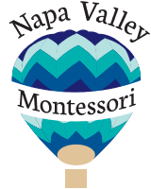
120 West American Canyon Road M-11
American Canyon, CA 94503
www.napavalleymontessori.com
Napa Valley Montessori
Elementary Summer Camp 2017
Join us for 2 week sessions full of fun and exploration!
We provide a safe enriching environment for children from K-6th grade in American Canyon and the surrounding communities.
Register today: info@napavalleymontessori.com
Session 1:  What’s Bugging You?  Week of July 3rd and July 10th  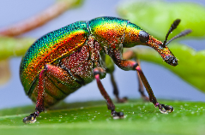  Hands on activities to learn about insects that live locally and around the globe | Session 2:  Under the Sea  Week of July 17th and July 24th  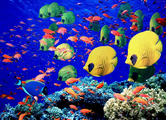  Dive down below to explore the coral reefs, animals and beauty of the sea
Session 3:  Around the World in 10 Days  Week of July 31st and August 7th  Pack your bags for a fantastic adventure through the continents | Session 4:  Transportation  Week of August 14th and 21st  Buckle your seatbelt as we investigate the various forms of transportation.
The Montessori classroom provides invigorating hands on lessons for the children to explore on a daily basis.
ENROLL TODAY FOR A SUMMER OF FUN!

